“Leap Of Mankind”

|  | Dilawar Singh  Kwantlen Polytechnic University  Surrey, Canada  Dilawar.singh@email.kpu.ca |  |
| --- | --- | --- |

# ABSTRACT

## In This Project Named “Leap of Mankind”. I chose this name for project because I feel that space Exploration is a great advancement for mankind which has opened many doors for human. I have created a rocket launching scenario. When the program starts, the rocket is standing at Earth, ready for user to launch it. When user launches the rocket, the Y-Axis value changes which makes the rocket Fly, once the Rocket leaves the earth Environment, the rocket Enters into Space where Rocket is Shown moving. At the End the Satellite

# INTRODUCTION

# This project is based on my interest and facination about space and astronomy. I chose this project because this project uses some of advanced concepts of programming language which in this case is Java and the Working Environment of processing. i got a chance to practice and polish my programming skills.

# Overall DESIGN PROCESS

# Program Uses multiple classes to create objects which are displayed on screen. The movable objects are created by using Generic Type arrayList functions which help managing and designing easier. There are multiple interfaces which are implemented throughout the program.

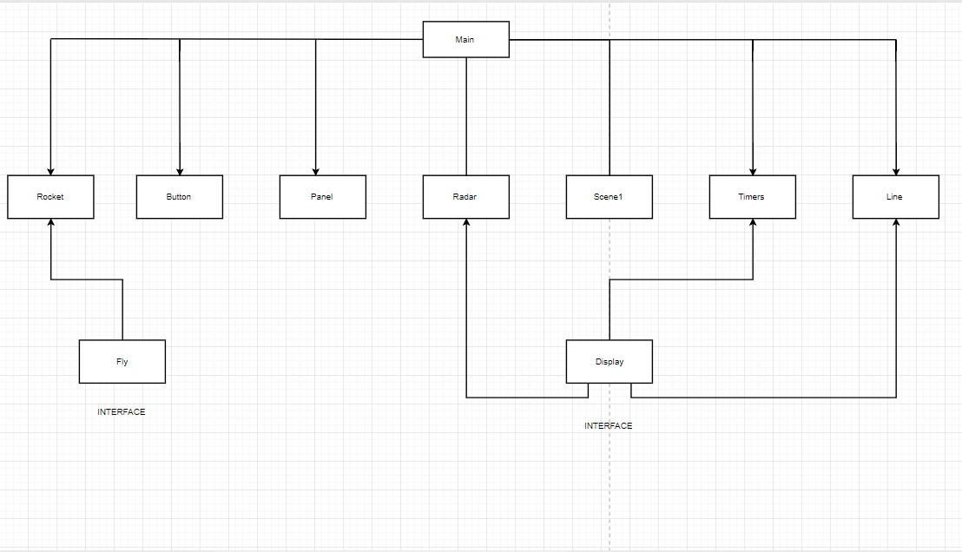

Figure :- Flow Chart Depicting Different classes used in coding this project

# Algorithm DESIGN

The Overall working of this program is as follows :

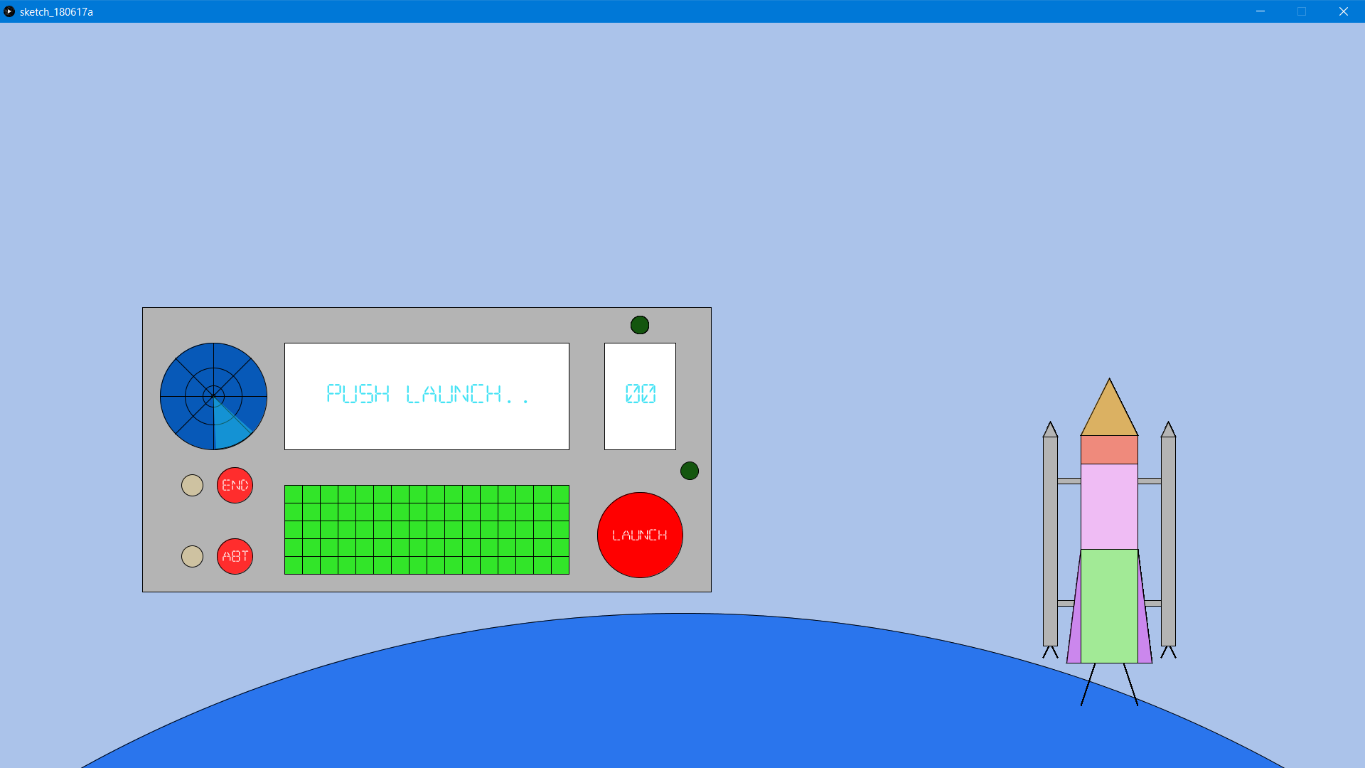

Figure :- User pushes the Launch Button

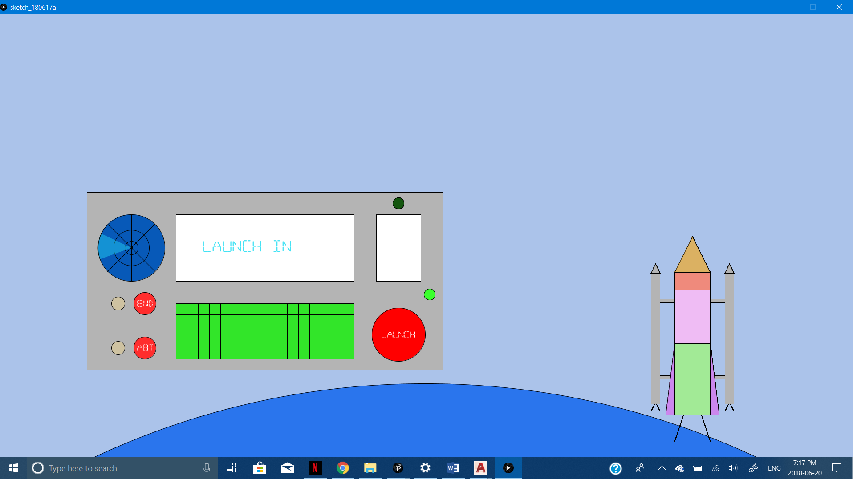

Figure :- Pushing Launch Button Initiates the Countdown launch sequence.

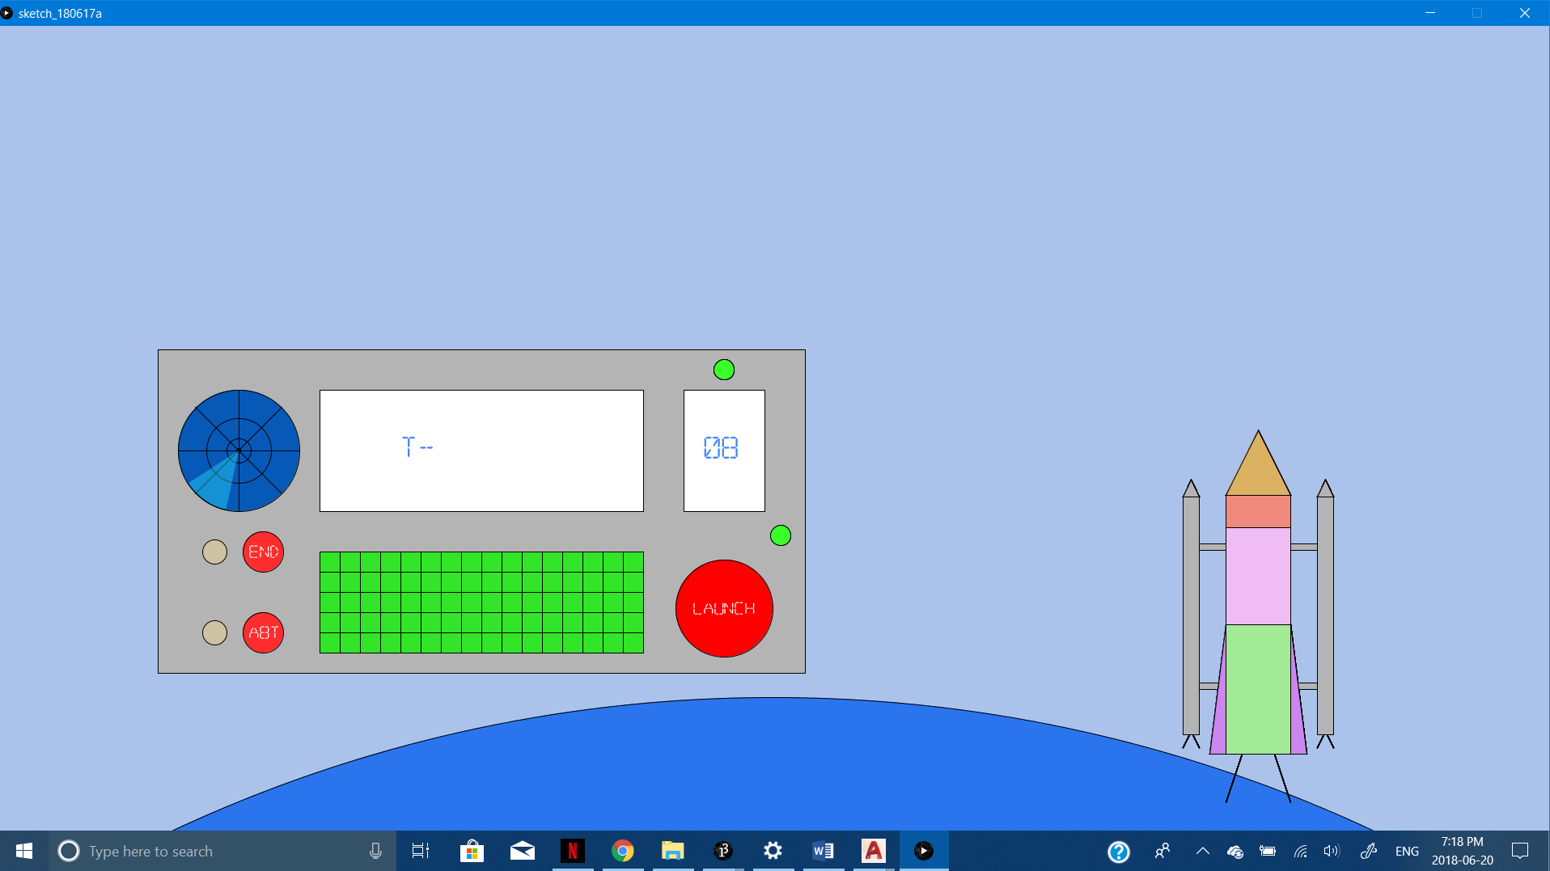

Figure :- It displays messages on large display of control panel and T- on small LED. The Counter LED Blinks to give User much More Visual Interface.

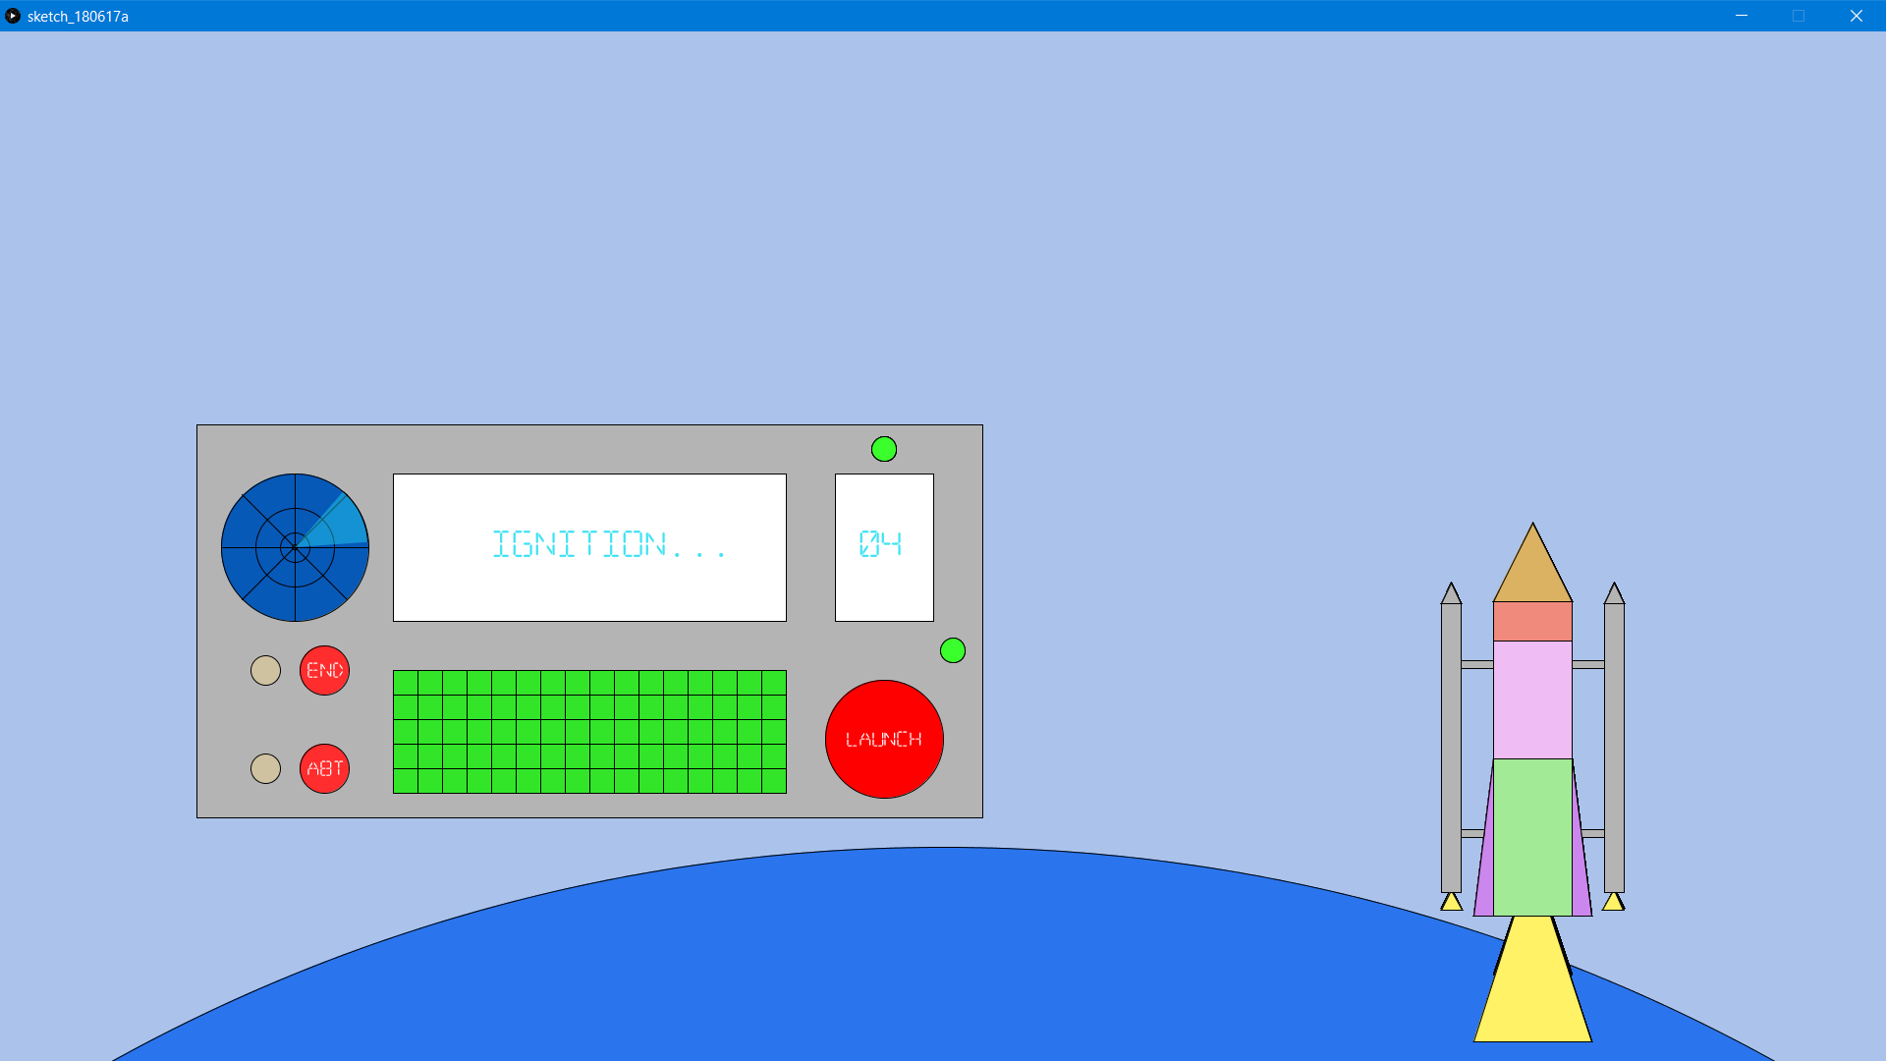

Figure :- When T- reaches 4, ignition in main Engine and Boosters Starts.

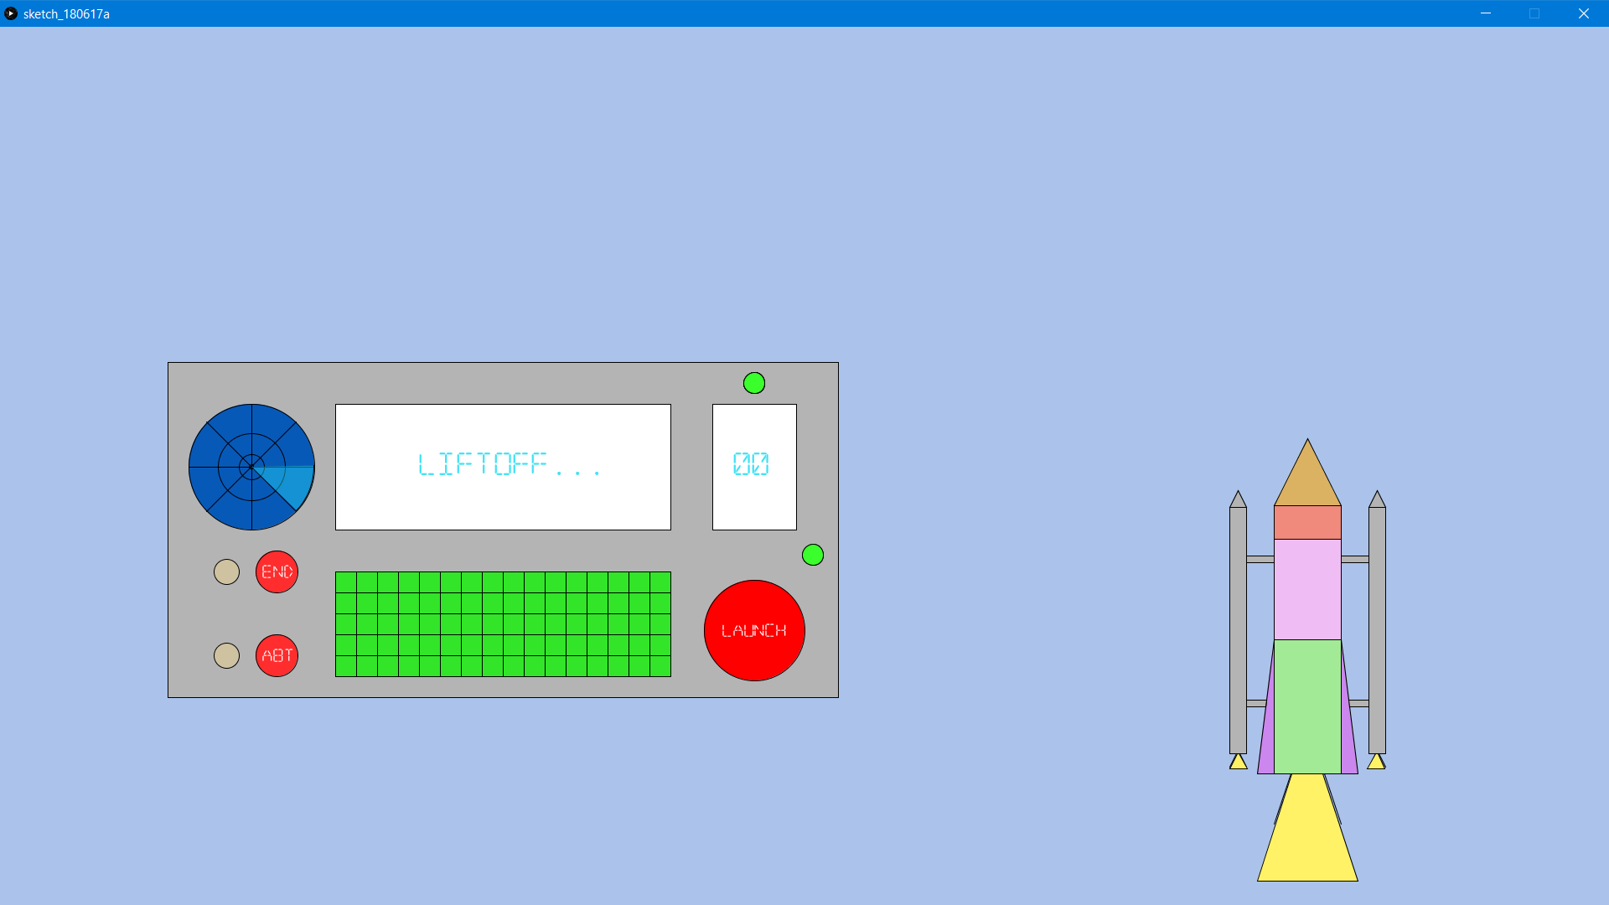

Figure :-Rocket liftoffs when T- becomes 0,

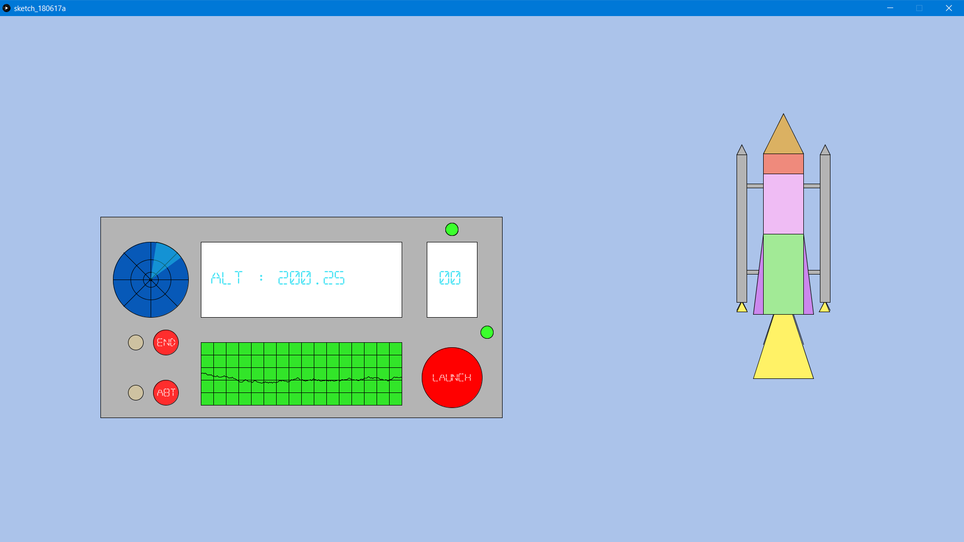

Figure :- After the Liftoff the Main Display on panel displays the Altitude of Rocket in negatives of Y-axis

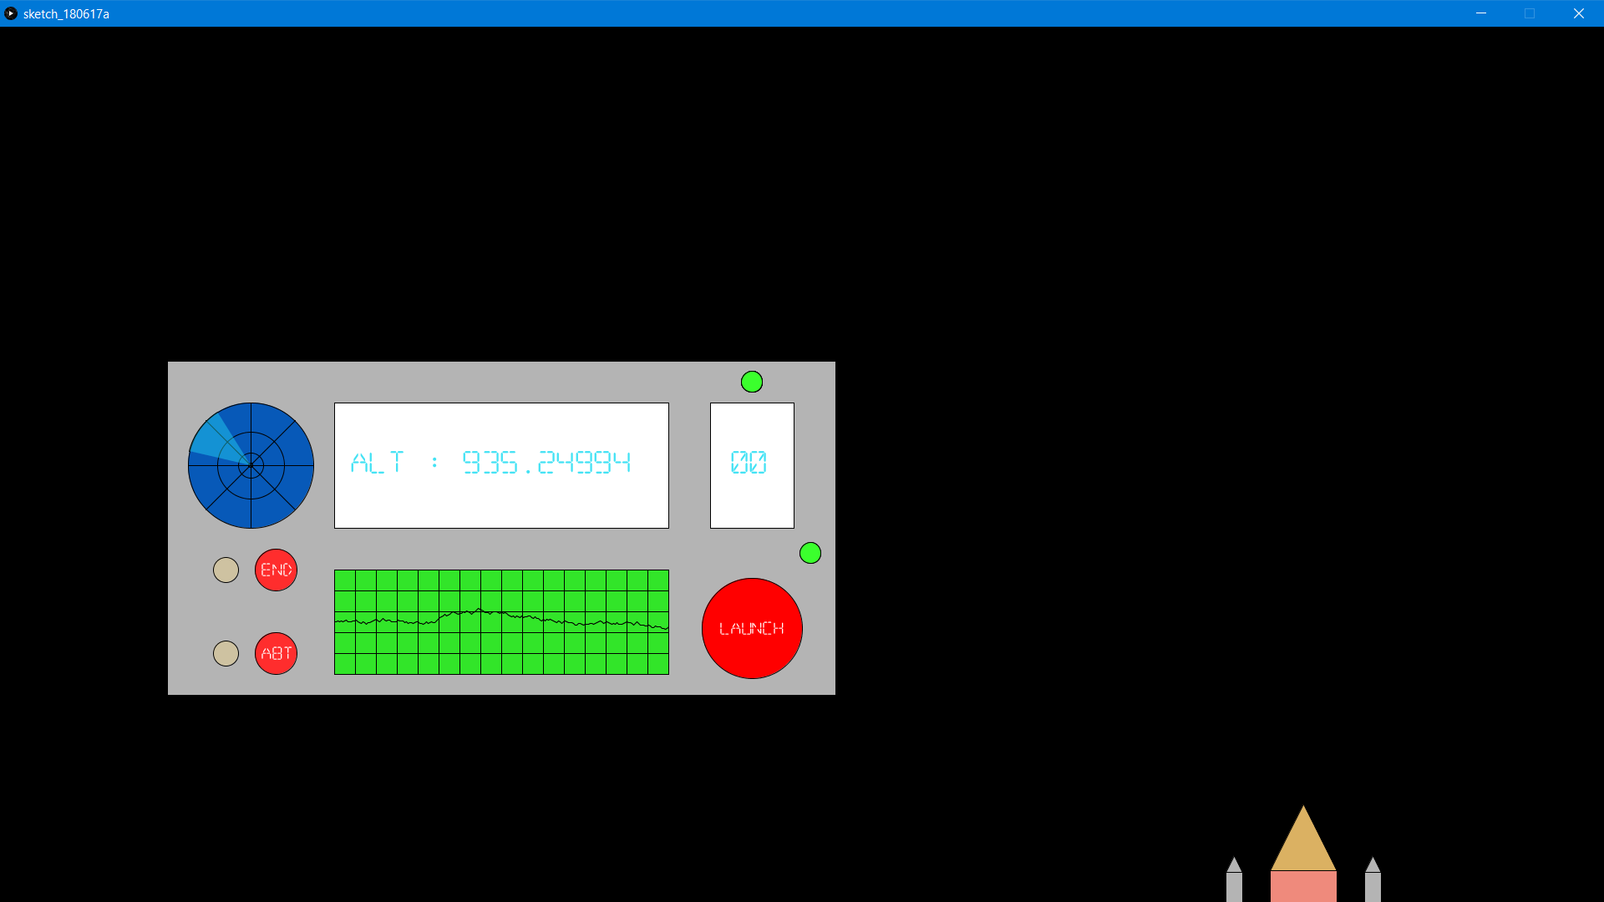

Figure :- When the Altitude becomes -440 (adjusted as per screen size) the previous rocket is removed from arrayList and new Rocket Ascends from bottom of screen which is reoccurring behavior of Rocket.

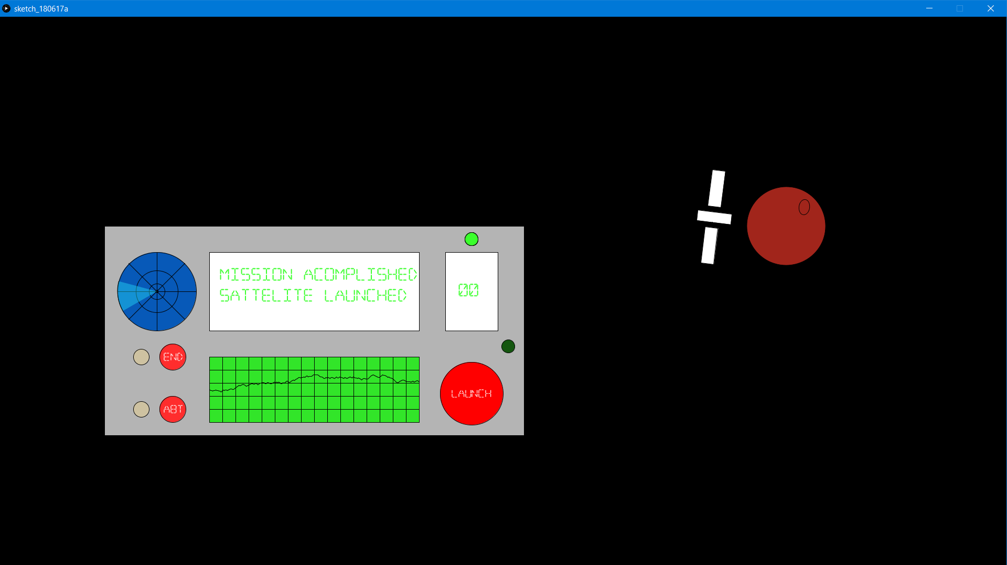

Figure :- User can end the Mission by Pressing End button which will stop Rocket From displaying and Mars planet will be shown around which a satellite (Launched by Our Rocket) revolves and user get Mission Accomplished message on Main Display.

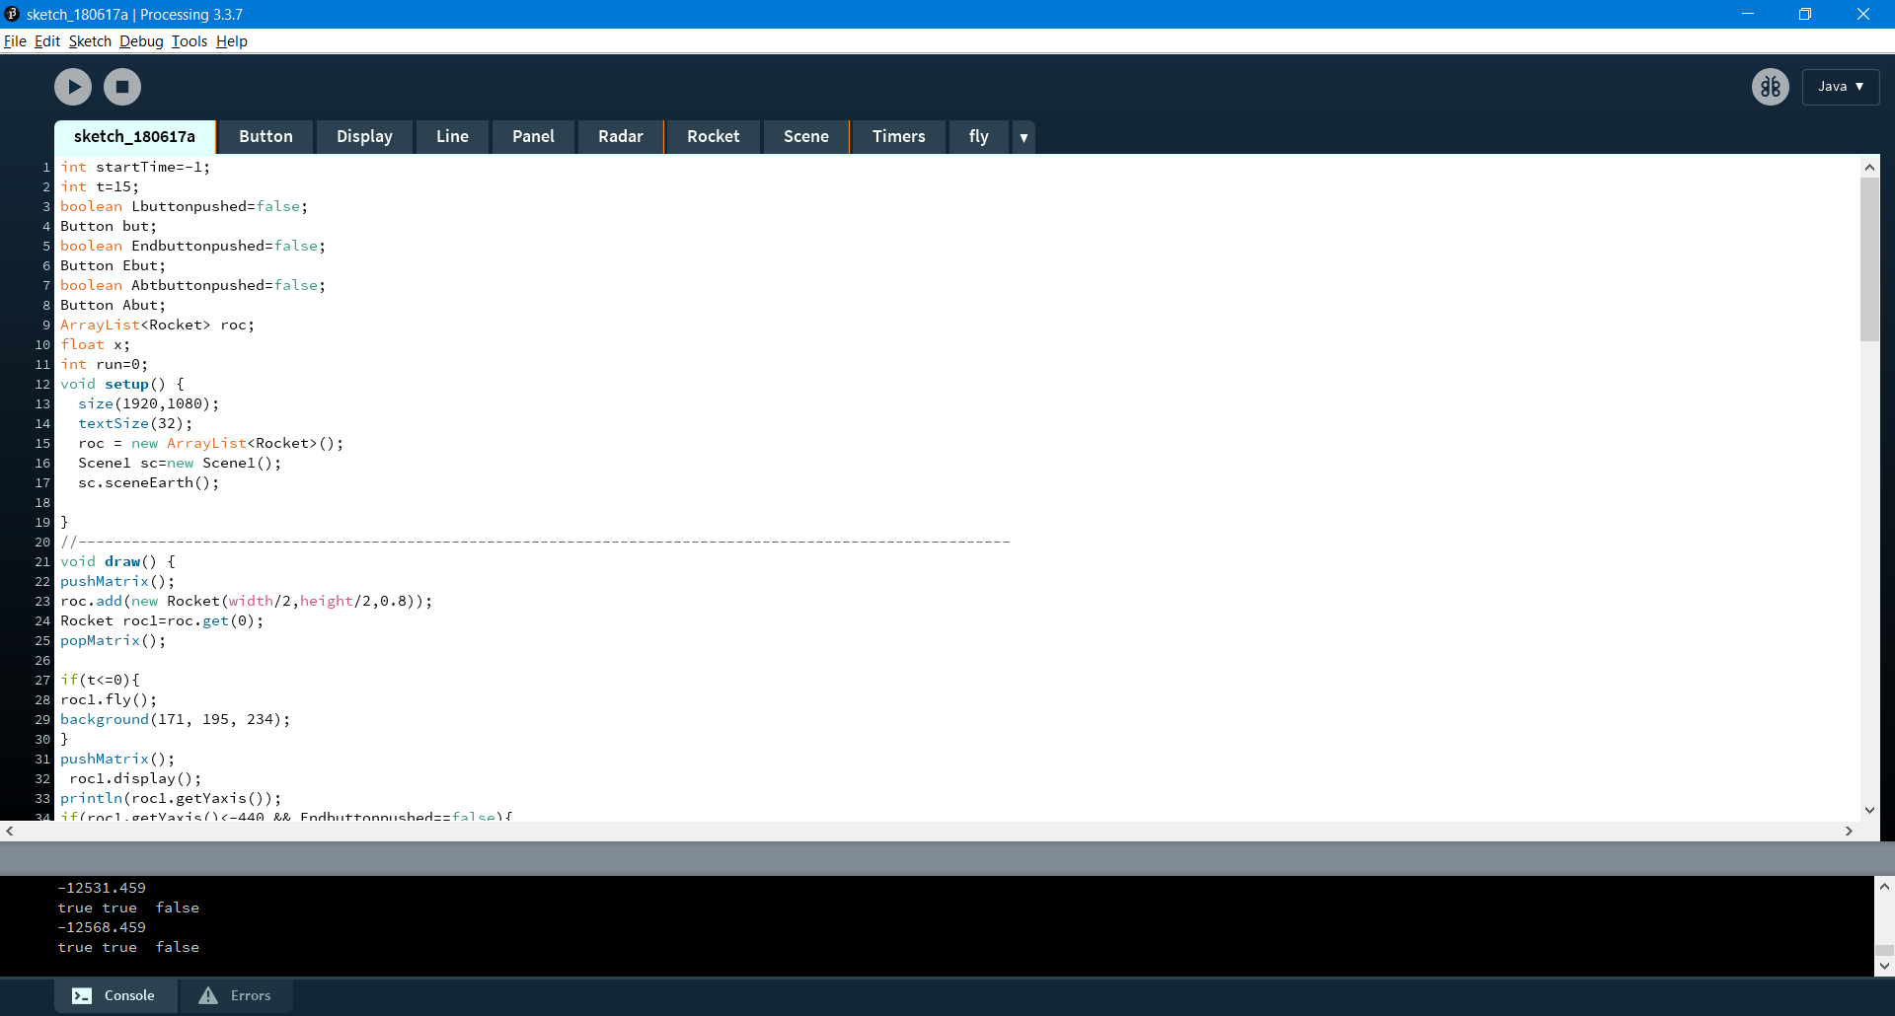

Figure :-THIS CODE IS IMPLEMENTED USING ADVANCED CONCEPTS LIKE GANERIC ARRAYLISTS AND CUSTOM PShapes.

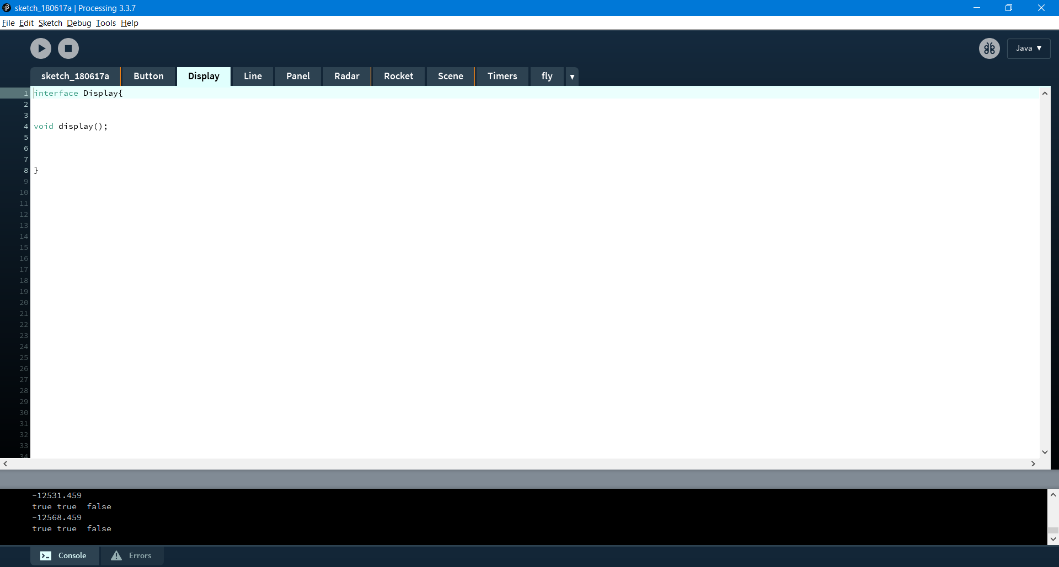

Figure :- It uses Interfaces which makes the code clean.

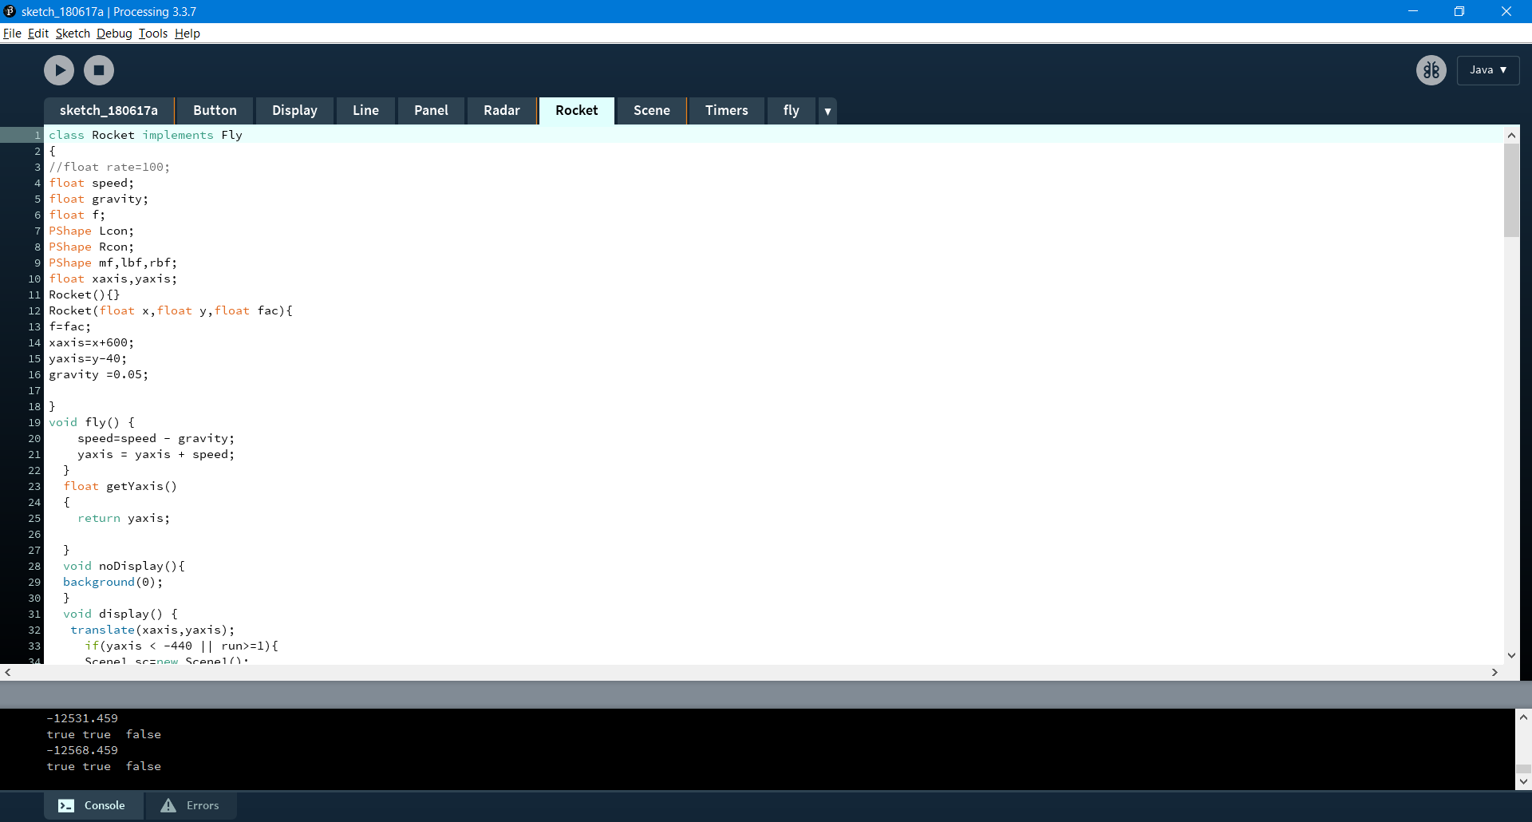

Figure :-Pure Mathematics is used to make things move.

# 

Figure :-This Class is Used to display all text on Control Panel.

# Conclusion

# in a nutshell, i would like to thank dr. K.J. to give students an assignment like this which will surely help in academic and career success as by completing this assignment, i have learned many new things especially the programming software ‘Processing’. I have learned various new things which will surely help me in my futur courses.

# REFERENCES

1. Processing Reference books and Libraries. Retrieved on May 24,2018

<https://processing.org/reference/>

1. Stack Overflow Developer’s Forum. Retrieved on May 28,2018

https://stackoverflow.com/

1. Processing Video Tutorials by Daniel Shiffman. Retrieved on May 24,2018.

<https://processing.org/tutorials/>

1. Introduction to Java Programming and Data Structures Student Value Edition (3rd ed). (2017). Pearson College Div.